

INFORMATION TECHNOLOGY EDUCATION DEPARTMENT

ITPROG2
(Computer Programming 2 for IT)

EXERCISE
4

Structures

score

Justine Guillermo  Name of Student | Jay-ar Lalata  Name of Professor
Date Performed | 01/19/19  Date Submitted

- OBJECTIVES:
At the end of the experiment students must be able to:

Cognitive
- Enumerate the ways of using structure

Psychomotor:
- Write a program using structure.

Affective
- Appreciate the concept behind this experiment.

- BACKGROUND INFORMATION
C++ arrays allow you to define variables that combine several data items of the same kind but structure is another user defined data type which allows you to combine data items of different kinds.

Structures are used to represent a record, suppose you want to keep track of your books in a library. You might want to track the following attributes about each book:
- Title
- Author
- Subject
- Book ID
To access any member of a structure, we use the member access operator (.). The member access operator is coded as a period between the structure variable name and the structure member that we wish to access. You would use struct keyword to define variables of structure type.

- LABORATORY PROCEDURE:

Activity 1: Player’s Record
Write a C++ program to keep records and compute for the scores of 5 players. The information of each player contains: Nickname, Age and two best played scores.

The program will prompt the user to choose the operation of records from a menu as shown below:
==============================================
MENU
==============================================

- Add record
- View players records
- Compute for the average
- Show the player(s) who gets the max average.
- Show the player(s) who gets the min average.
- Exit

- QUESTION AND ANSWER:
#include <iostream>
#include <iomanip>
#include <string>
#include <algorithm>
#include <stdlib.h>

using namespace std;

struct game{
int age;
char nickname[50];
int score1;
int score2;
};

int avg (int x);

int main()
{
int z,y, ave[5],i=0;
char ch,choice;
game player[5];
for(int l=0; l<5; l++)
{
player[l].age=0;
player[l].score1=0;
player[l].score2=0;
}

do
{
system ("cls");
cout << "======================================" << endl;
cout << " MENU" << endl;
cout << "======================================" << endl;

cout << endl << endl;
cout << "1. Add record" << endl;
cout << "2. View player records" << endl;
cout << "3. Compute for the average" << endl;
cout << "4. Show the player(s) who gets the max average" << endl;
cout << "5. Show the player(s) who gets the min average" << endl;
cout << "6. Exit" << endl;

cout << endl << endl;

cout << "Please choose a number from the following choices: ";
cin >> choice; // inputs the choice of the user

switch (choice){
case '1': // case 1 lets the user enter a record of a player
cout << endl << endl;

if (i<5){ // filter if the user exceeded five(5) players
cout << "Please enter your record" << endl << endl;
cout << "PLAYER " << (i+1) << endl;

cout << "Nickname: ";
cin >> player[i].nickname,50; //stores nickname

cout << "Age: "; //stores age
cin>> player[i].age;

cout << "Best Score 1: "; //stores score 1
cin >> player[i].score1;

cout << "Best Score 2: "; //stores score 2
cin >> player[i].score2;

cout << endl;
i++;

cout << "Would you like to choose again? (y/n)";
cin >> ch;}
else{
cout<<"Five Players Only"<< endl;
system ("pause");}

system("CLS");
break;
case '2': //case 2 prints out the records of the players
cout << endl << endl;
cout<< setw(10) << "Player #"
<< setw(30) << "Nickname"
<< setw(10) << "Age"
<< setw(15) << "Score1"
<< setw(15) << "Score2";

cout.setf(ios::fixed);
cout.setf(ios::showpoint);
cout.precision(2);

for(y=0; y<5; y++)
{
cout << endl;
cout<< setw(10) << y+1
<< setw(30) << player[y].nickname
<< setw(10) << player[y].age
<< setw(15) << player[y].score1
<< setw(15) << player[y].score2;
}
cout << endl << endl;
cout << "Would you like to choose again? (y/n)";
cin >> ch;
system("CLS");
break;
case '3': //case 3 computes the average(score1+score2/2) of each players
cout << endl << endl;
cout<< setw(10) << "Player Name" << setw(15) << "Average"<<endl;
for(y=0; y<5; y++)
{
cout<< setw(10) << player[y].nickname;

ave[y]=(player[y].score1+player[y].score2)/2;

cout <<setw(15)<< ave[y] << endl;
}

cout << endl << endl;
cout << "Would you like to choose again? (y/n)";
cin >> ch;
system("CLS");
break;
case '4': //finds the highest average
int f, max ,m;
for(y=0; y<5; y++) //gets all the average of all players
{
ave[y]=(player[y].score1+player[y].score2)/2;
}
max = ave[0];
for(f=1; f < 5; f++)
{

if(ave[f]>max){

m=f;
}
}
cout <<endl<<endl<< "The player who got the highest average is " << player[m].nickname<<endl;

cout << endl << endl;
cout << "Would you like to choose again? (y/n)";
cin >> ch;
system("CLS");
break;
case '5': //finds the lowest average
int t,min,g,h;
for(y=0; y<5; y++) //gets all the average of all players
{
ave[y]=(player[y].score1+player[y].score2)/2;
}
for (h=0;h<5;h++){
if (ave[h]=0){
ave[h]=1929391;
}
}
min = ave[5];
for (t=5;t>1;t--){
if (ave[t]<min){
g=t;

}
}
cout << endl << endl << "The player who got the lowest average is "<< player[g].nickname<<endl;
for (h=0;h<5;h++){
if (ave[h]=1929391){
ave[h]=0;
}
}
cout << endl << endl;
cout << "Would you like to choose again? (y/n)";
cin >> ch;
system("CLS");

break;

case '6':
return (0);

default:
cout << endl <<endl<<"invalid choice!";
cout << endl << endl << "Would you like to choose again? (y/n)";
cin >> ch;

}
} while (ch == 'y' || ch == 'Y'|| ch== '1');

return 0;
}

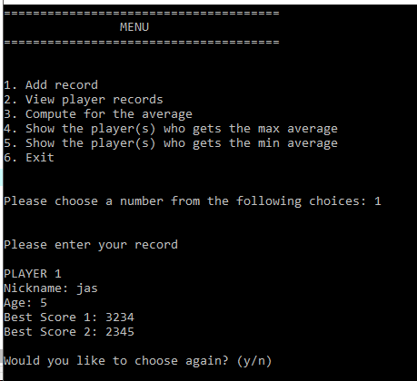
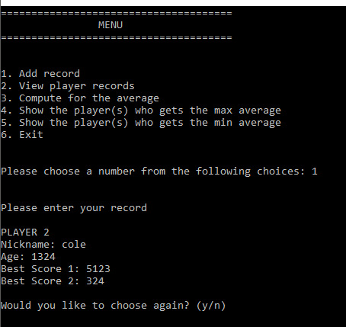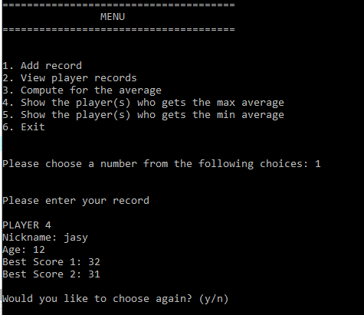
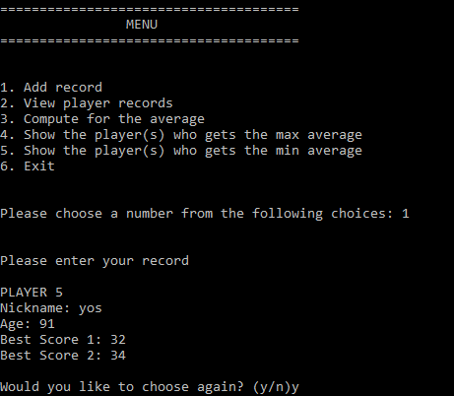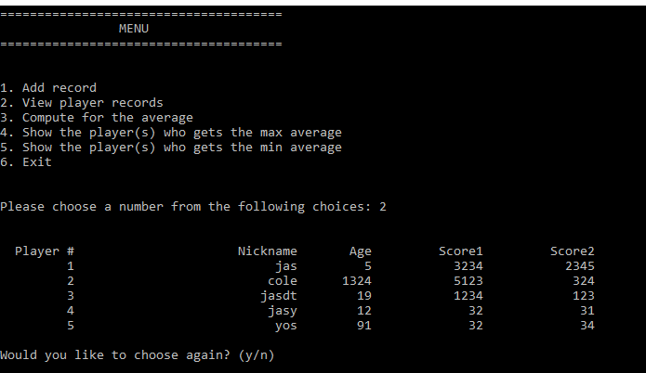
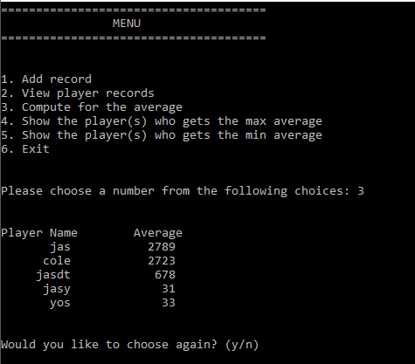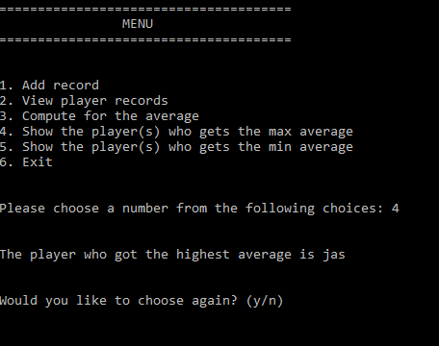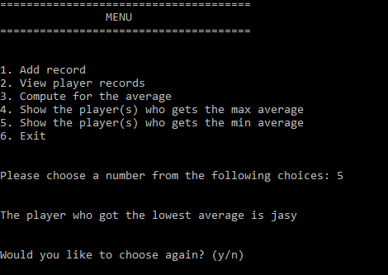
1. What are the ways to use or declare structure in your program?

You can declare a structure by using the syntax
struct structure_name
{
data-type member-1;
data-type member-2;
data-type member-3;
data-type member-4;
};
2. How do you access a member in a structures?

to acces a member the syntax is;
structure-name.element-name

V. ASSESSMENT

Department | Information Technology
Subject Code | ITPROG2
Description | COMPUTER PROGRAMMING 2 for IT
Term/Academic Year

Note: The following rubrics/metrics will be used to grade students’ output in the lab Exercise 2.
Trait | (Excellent) | (Good) | (Fair) | (Poor)
Requirement Specification (30pts) | Able to identify correctly all input and output and provide alternative.  (28-20pts) | Able to identify correctly all input and output  (25-17pts) | Able to identify only one input or output  (22-14pts) | Unable to identify any input and output  (20-11pts)
Data type (20pts) | Able to apply required data type or data structure and produce correct results (18-20pts) | Able to apply required data type or data structure and produce partially correct results (15-17pts) | Able to identify required data type or data structure but does apply correctly (12-14pts) | Unable to identify required data type  (9-11pts)
Input Validation (20pts) | The program works and meets all specifications. Does exception al checking for errors and out-of- range data (18-20pts) | The program works and meets all specifications. Does some checking for errors and outof- range data (15-17pts) | The program produces correct results but does not display correctly Does not check for errors and outof- range data (12-14pts) | The program produce s incorrect results (9-11pts)
Free from syntax, logic, and runtime errors (10pts) | Unable to run program (10pts) | Able to run program but have logic error (8-9pts) | Able to run program correctly without any logic error and display inappropri ate output (6-7pts) | Able to run program correctly without any logic error and display appropriate output (5pts)
Delivery (10pts) | The program was delivered on time (10pts) | The program was delivered after 5 minutes from the time required. (8-9pts) | The program was delivered after 10 minutes from the time required. (6-7pts) | The program was delivered after 15 (or more) minutes from the time required. (5pts)
Use of Comments  (10pts) | Specific purpose is noted for each function, control structure, input requirements, and output results. (10pts) | Specific purpose is noted for each function and control structure. (8-9pts) | Purpose is noted for each function. (6-7pts) | No comments included. (5pts)

Topic | Structures
Lab Activity No | 2
Lab Activity | Ways of Structures
CLO | 1,2
Requirement Specification (30pts)
Data type (20pts)
Input Validation (20pts)
Free from syntax, logic, and runtime errors (10pts)
Delivery (10pts)
Use of Comments (10pts)
TOTAL

